**EXCEL ASSIGNMENT - 1**

|  |
| --- |
|  |

**1.What do you mean by cells in an excel sheet?**

MS Excel is a spreadsheet, where one can record data in the form of tables. A cell is a rectangular area formed by the intersection of a column and a row. Columns are identified by letters (A, B, C), while rows are identified by numbers (1, 2, 3).

**Cell, Column, Row and Cell Address:**

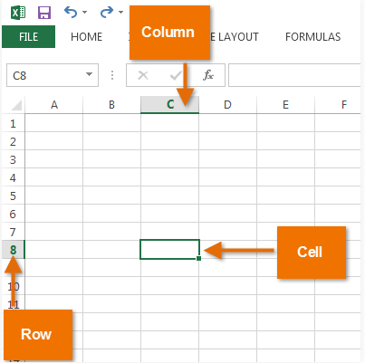 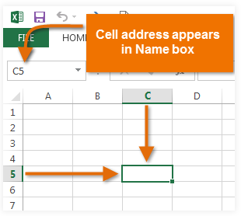

**Reference:**

<https://edu.gcfglobal.org/en/excel2013/cell-basics/1/>

<https://byjus.com/govt-exams/ms-excel-basics/>

**2.How can you restrict someone from copying a cell from your worksheet?**

Under the Review toolbar, we can protect the sheet

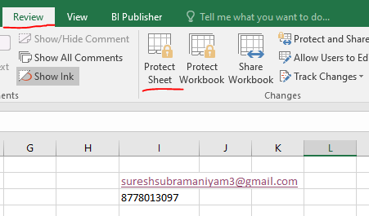

Even we can enter password to protect

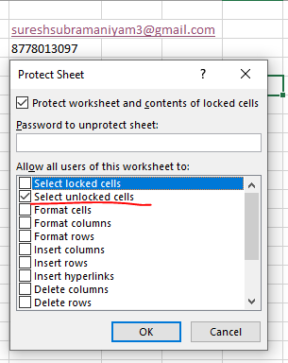

Once Protection is enabled, if we try to alter the cell it will throw warning message as captured below.

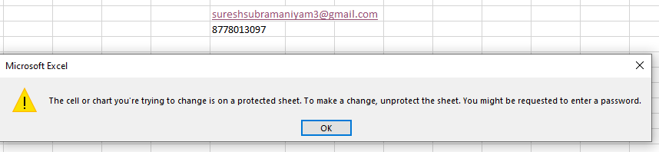

**Reference:**

[**https://support.microsoft.com/en-us/office/protect-a-worksheet-3179efdb-1285-4d49-a9c3-f4ca36276de6**](https://support.microsoft.com/en-us/office/protect-a-worksheet-3179efdb-1285-4d49-a9c3-f4ca36276de6)

**3. How to move or copy the worksheet into another workbook?**

Right-click on the worksheet that is actually what to be moved to another workbook.

Click “MOVE or COPY “

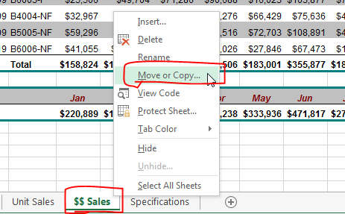

Select (new Book) in order to move into another workbook.

Click “ok” then selected Sheet will be moved into another new workbook.

**Note:**

* We can drag and drop the sheet into same workbook also
* Can click “create a copy” to make a duplicate copy of the worksheet

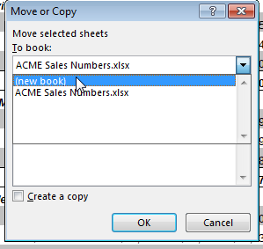

**Reference:**

[**https://www.howtogeek.com/220677/how-to-copy-or-move-a-worksheet-into-another-workbook-in-excel**](https://www.howtogeek.com/220677/how-to-copy-or-move-a-worksheet-into-another-workbook-in-excel)

**4. Which key is used as a shortcut for opening a new window document?**

To create a new workbook Ctrl + N

 To open an existing workbook Ctrl + O

To close the current workbook Ctrl + W

To close Excel Ctrl + F4

To move to the next sheet Ctrl + PageDown

To move to the previous sheet Ctrl + PageUp

**5. What are the things that we can notice after opening the Excel interface?**

This is how the Excel interface looks like

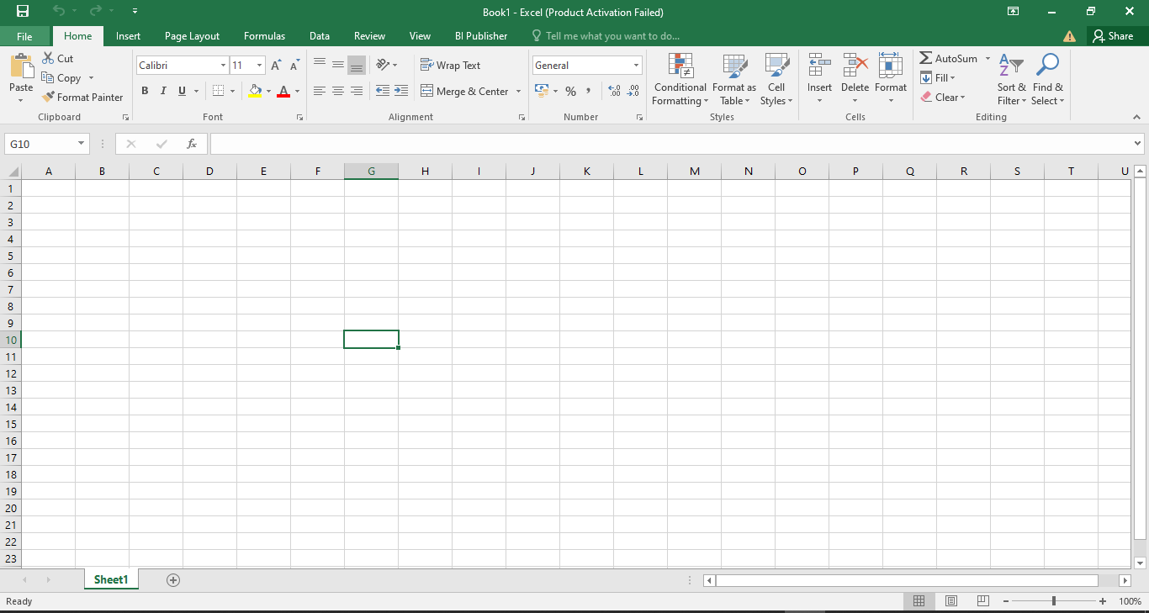

**Menu Bar:**



**File, Home, Insert, Page Layout, Formulas, Data, Review, View……**

**Tool Bar ribbon:**



**Other components:**

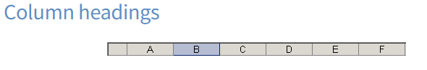

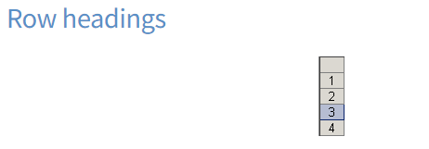

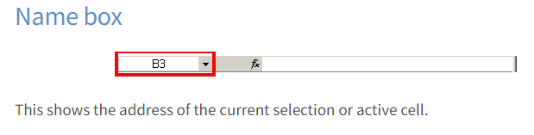

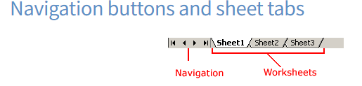

Cell Pointer and Cell Address

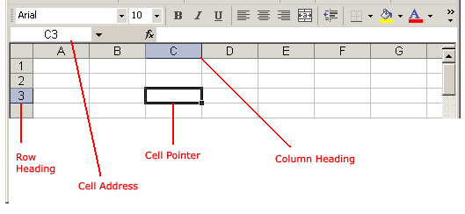

**Reference:**

[**https://edu.gcfglobal.org/en/excelxp/identifying-basic-parts-of-the-excel-window/1/**](https://edu.gcfglobal.org/en/excelxp/identifying-basic-parts-of-the-excel-window/1/)

**6. When to use a relative cell reference in excel?**

Whenever we need to apply the same formula to remaining rows, we can apply the formula for a single cell and then we can drag and drop it to the remaining cells. So that relatively excel will make use the cell address to adjust the formula accordingly.

Example shown as below

Addition operation on B2 and A2

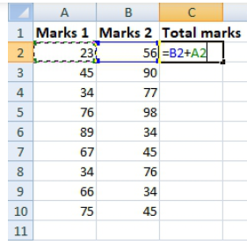

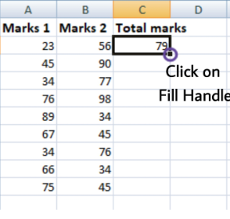

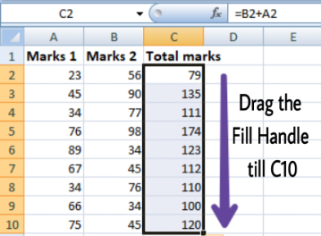

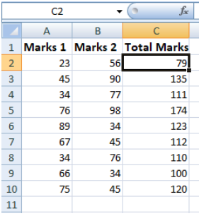

Relatively it is calculated for remaining rows.

If we check the C3 cell relatively formula has been formed.

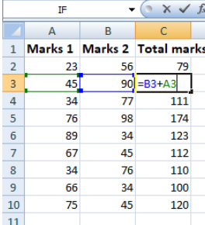

**Reference:**

**<https://www.geeksforgeeks.org/relative-and-absolute-cell-references-in-ms-excel/>**